Developer Guide

jWebSocket
Stock Ticker
1.0

- Overview
StockTicker Demo is an application showing and manages real time data using a Stock ticker. Its primary approach is to improve the potentials to the jwebsocket framework to work with stock ticker applications.
- Infrastructure, Model, Approach
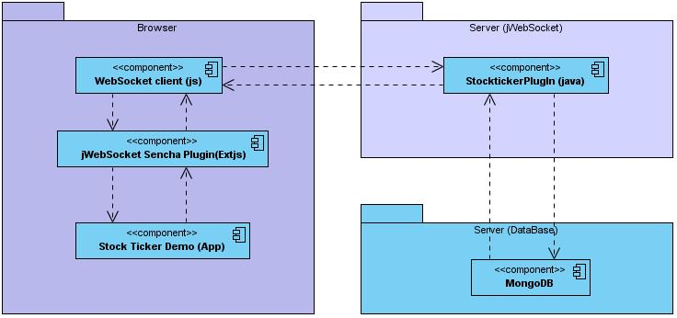
Picture 1: This diagram describes the Stock Ticker Demo infrastructure

Description:
With the Stock Ticker Demo you can show and manage the data in real time using the jwebsocket framework. At the client side you need have a browser that support WebSocket protocol. jWebsocket client use the websocket protocol to establish communications with the jwebsocket server which is responsible to distribute each action at the application. It has a component caller StocktickerPlugin, which is responsive to manage the communication with the Mongo Data Base server.

- Requirements and prerequisites
The prerequisites for the continued development of the solution are:
- Database Mongo DB
- Connecting to the network

- Modules, Structure
The main aspects that describe the organizational structure Stock Ticker application are reflected below:
At the server side:
Project name: | Stock Ticker Demo
Sources code locations at the SVN server: | http://10.208.7.203/svn/jwebsocket/trunk/Projects/jWebSocket/1.0/source-code/jWebSocketPlugIns/JWebSocketStockTickerPlugIn/
SVN branch: | jWebSocket-1.0
Maven dependencies: | 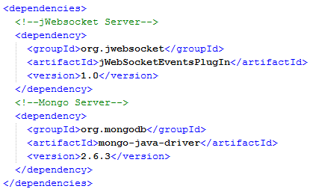
JAR module: | jWebSocketEventsPlugIn-1.0.jar
Package structure: | Espacio de nombre base:  jWebSocketStockTickerPlugIn 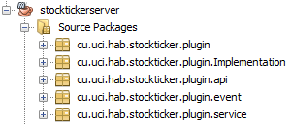
cu.uci.hab.stockticker.plugin:
Have a plugin that implements all applications functionalities.
cu.uci.hab.stockticker.plugin.Implementation:
Have the interface implementations
cu.uci.hab.stockticker.plugin.api:
Have the interface that will be implemented by the applications.
cu.uci.hab.stockticker.plugin.event:
Have a events implementations of the application.
cu.uci.hab.stockticker.plugin.service:
Have the service implementation of the application.

At the client side:
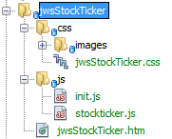
The client side using the following java scripts files:
- stockticker.js: Allow to show and manage the data arriving from server side.
- init.js: Is responsive to start the applications.
- Also we use the htm and css file to make the user interface:
- jwsStockTicker.html: In this file you can find all html source code to the application.
- jwsStockTicker.css: Here you can find all css source code to the application.

- Source code structure
At the server side:
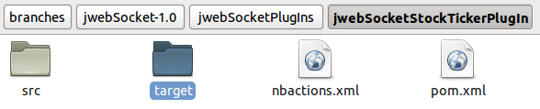

Element descriptions:
- src: This directory contains all the source code of classes and libraries of the solution.
- target: This directory temporarily stores the compiled source code, its content is not included in the version control.
- nbactions.xml: project configuration file created by the NetBeans IDE. The contents of this file may or may not be in version control, to include depends on the decision of the development team.
- pom.xml: Configuration file for jWebSocketServer module that contains information about the project and details of the settings used by Maven to build the project.
At the client side:
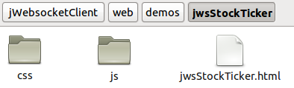
Elements descriptions:
- css: In this directory you can find the css files to the application.
- js: In this directory you can find the all js file using to make the application.
- jwsStockTicker.html: A hypertext file. These are usually static content, not dynamic. Includes HTML application.

Standard code:
The standard code is an artifact generated by the developer methodology and you can find it at the following URL:
http://10.208.7.203/svn/proyecto/trunk/Thesis_Projects/Financial_App_Demo_Roylandi/Engineering/Plantilla Estandar de codigo.odt

Library and tools using
- JWebSocket framework, LGPL license.
- JavaScript library ExtJS, Version 4.0

Network protocols used
The SockTicker Demo was developer using the jwebsocket framework, it use the WebSocket protocol, this technology have a bidirectional communications and full-duplex with only one socket TCP to establish the communication.

Details description of the application code
At the server side:
Package structure at the server side
The org.jwebsocket.stockticker.plugin package is composing for the following class:
Class | Description
StocktickerPlugIn | This class represents the used plug-in to launch and listen to happenings, those which will serve to establish communication with the web application of the side of the client.

Clase: org.jwebsocket.stockticker.plugin.StocktickerPlugIn
Type | Method | Description
void | processEvent(CreateUser aEvent, C2SResponseEvent aResponseEvent) | Prosecute the CreateUser happening coming of the client, after creating the same, is notified to the same one.
void | processEvent(Login aEvent, C2SResponseEvent aResponseEvent) | prosecute the login event coming of the client, after being verified if exists the same, is notified to the same one.
void | processEvent(GetTickets aEvent, C2SResponseEvent aResponseEvent) | prosecute the GetTickets event coming of the client, which keeps notifying constantly to the client
void | processEvent(Buy aEvent, C2SResponseEvent aResponseEvent) | prosecute the buy event coming of the client.
void | processEvent(ReadBuy aEvent, C2SResponseEvent aResponseEvent) | prosecute the ReadBuy event coming of the client, which keeps notifying constantly to the client.
void | processEvent(Sell aEvent, C2SResponseEvent aResponseEvent) | prosecute the sell event coming of the client.
void | processEvent(Combobox aEvent, C2SResponseEvent aResponseEvent) | prosecute the Combobox event coming of the client, which keeps notifying constantly to the client.
void | processEvent(Chart aEvent, C2SResponseEvent aResponseEvent) | prosecute the Chart happening coming of the client, which keeps notifying constantly to the client.
void | processEvent(Logout aEvent, C2SResponseEvent aResponseEvent) | prosecute the Logout event coming of the client, which after eliminating the connector, it is notifies to the client.

The org.jwebsocket.stockticker.plugin.service package is composing for the following class:
Class | Description
StocktickerService | Contains the services implementation of the application.

Clase: org.jwebsocket.stockticker.plugin. service.StocktickerService
Type | Method | Description
Boolean | createUser(IUser aUser) | store in the base of data the registered users.
Boolean | login(IUser aUser) | Check that the user exists in the base of data
BasicDBObject | valuesOfRecords(Integer aId, String aName) | generate the random values to be shown in the Stock Ticker.
List<IRecord> | listRecords() | Obtains a list of company with the values of the base of data.
Boolean | buy(String aName, String aCant, String aUserLogin) | store in the base of data the purchases of instruments made by the user.
Boolean | sell(String aName, String aCant, String aUserLogin) | store in the base of data the sales made by the user.
List<IPurchasing> | readBuy(String aUser) | Obtains a list for user of the state of your deposit in the base of data.
List<String> | showComb(String aUser) | Obtains a list for user of the name of the company of your deposit in the base of data.
Integer | chart(String aUserLogin, String aName) | Obtains for user the value of the amount of the name of the company of your deposit in the base of data.

Source structure at the client side
The web applications at the client side are composed with two primary views. The first are composed with two forms registrations form and authentication form. The second view is the main of the application; there you can find the Stock Ticker, the deposit table and the deposit chart. Following you can see the primary functionalities in the source code at the client side application:
File: stockticker.js
Class: org.jwebsocket.stockticker.plugin. service.StocktickerService
Method | Description
function getWinLog() | Create the window of start-up that promotes the register and user authentication.
function getWinTicker() | Create the main window in which it is shown and promote the data for the user.
function getWinBuy() | Create the window of buying in which it is promoted the purchases made by user.
function getWinSell() | Create the window of selling in which it is promoted the sales made by user.
function getWinHistory() | Create the window shows the last ones 10 values of the price of the selected undertaking for the user.
function login() | Takes charge of sends to the servant the authenticated user, if it are erroneous lance a message of error, in other case the user accedes to the main window..
function register() | Takes charge of sends to the servant the registered user, if it are erroneous lance a message of error, in other case launches a satisfactory message.
function pctChange(val) | Takes charge of substitute a passed value for parameter for an image.
function pctTrend(val) | Takes charge of format the text that you are attacked for parameter. change the color.
function pctRn(val) | Takes charge of round a decimal number passed for parameter thirty points each places after the miserere.
addUsers:function(user) | Takes charge of add the authenticated user in a list.
deleteUser:function(user) | Takes charge of detele the user that it brings bad luck of the application in a list.
findUser:function(user) | Takes charge of return the position of an user of the list of authenticated.

Programming model
Stock Ticker Demo was based event-driven programming. This is a programming paradigm where the structure and the program execution are by the success happened in the system, defined by the users or make by itself.
- Frameworks, library and tools
To do the application was used EXT JS at the client side, it is a GNU licence, is a good framework to rich internet applications (RIA), is a new kind of applications that more advantage witch the traditional web application. Is use to have more visualization in the web applications.
Database and data persistence
Stock Ticker Demo use the documental Mongo Database. This kind of database working collection terms, it replace the entity term in the relational database. A collection is formed by the documents group. Also is used the document term, this term replace the term tuple or row. The documents are conformed for the element kind key-value.
This database is used to store users who are registered as well as purchases and sales of companies shares of each user, besides the prices of the companies information is stored. This database consists of an users collection, which stores the username and password of useres registered on the application. It also has a purchasing collection that stores the user and the deposit of the sale. On the other hand is used the ticker collection to store information about the prices of the companies.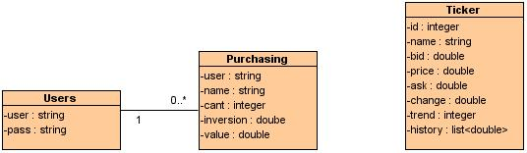

Entity: | users
Description: | This collection will contain the system user data.
Relations: | purchasing
Fields | Data type | Size | Description
user | String | - | The user will be a name selected by the user, this is the primary key to this collection.
pass | String | - | Password to the user

Entity: | tickets
Description: | This entity will contain the actions make by each system users.
Relations:
Field | Data type | Size | Description
name | string | - | Name of the instrument of the collection.
bid | double | - | Offer value to buy a instrument.
price | double | - | Price value to the instrument.
ask | double | - | Offer value to the buy the instrument.
change | double | - | Percent value to the difference to the actual price with the before.
trend | boolean | - | Dependence Price value
history | List<double> | - | List Price of the last ten who give the instrument

Entity: | purchasing
Description: | This entity will contain the actions make for each system user.
Relations: | user
Fields | Data type | Size | Description
user | string | - | User who is doing the shopping.
name | string | - | Name of the instrument purchased in the ticker collection.
cant | integer | - | Amount of actions to one instrument purchased.
inversión | double | - | Amount of money used at the purchase.
value | double | - | Value that is taking the instrument.

- Hardware
The Stock Ticker Demo no requires the additional hardware to work fine.

